**Milestone 4 - Full Photo View and Gestures**

***Xcode Project and Git Repository***

For this milestone, you can keep using the previous weeks' **MyPhotos** Xcode project.  Commit every step described below to the git repository!   Also make sure you have a meaningful description for every commit that outlines the changes you made since the last commit (another reason to commit often as this makes it less likely to forget the details of all your changes!).

***Full Photo View: Gestures***

For this milestone, the master and detail view stay unchanged.  Edit your main story board to insert a **full photo** view that optionally hides all bars and navigation items and displays a selected photo full screen. Redirect the photo selection segue (but *not the add button*) on the main collection view controller to move to the full photo view (instead of the detail view editor).  Add gesture recognisers to edit the photo (using the existing detail view controller) on a **single tap** and **left swipe** and **right swipe** gestures to flick through all the photos in full screen mode (note that a right swipe is fast, which is different from the existing slow left-to-right pan "*back*" gesture that you get for free from the navigation controller).  Here is an image of what your three views (collection, full photo, detail edit) should look now like:

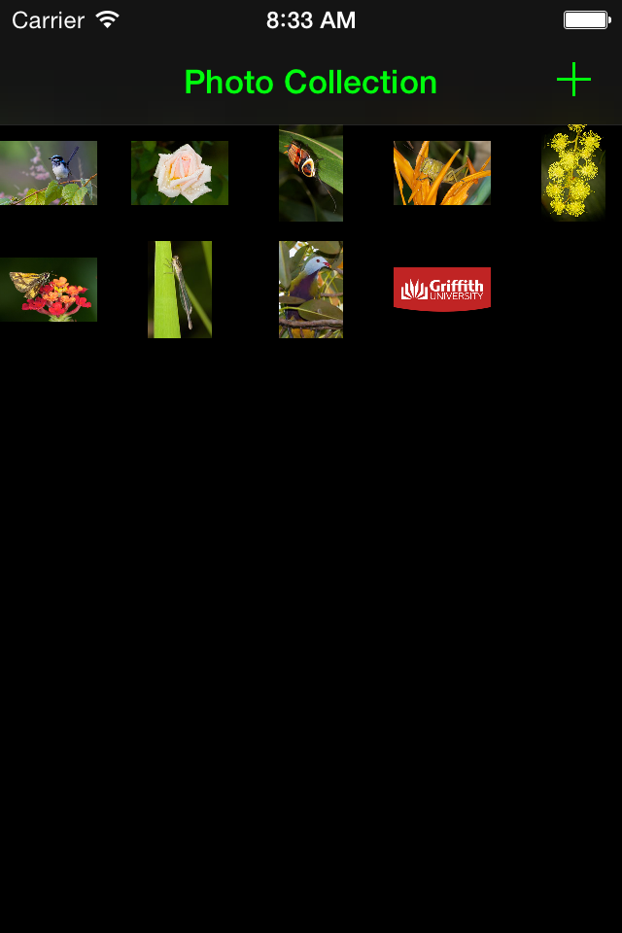

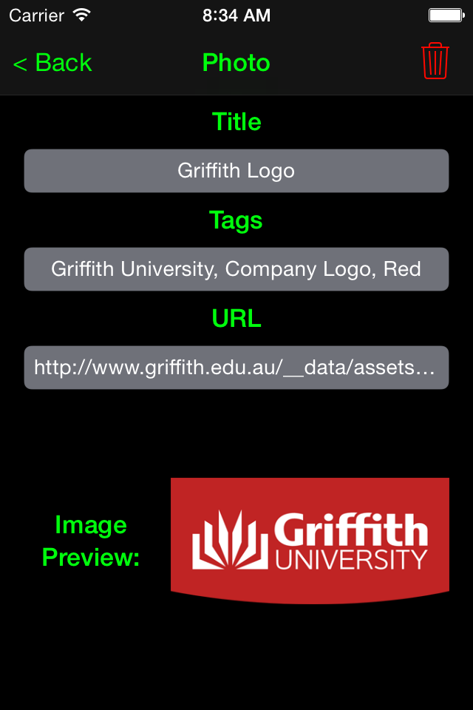

Make sure you link up the necessary actions, outlets, gesture recognisers, and segues!

***Tests***

Don't forget to add UI Tests for the additional views and gestures in your app!  Also, if you are making any changes to the model, make sure that you test for these in you Unit Tests (if you haven't make any changes, the previous weeks' unit tests should still work!)

***General Style***

Use best practices when writing your code.  E.g., use subclassing, delegation, and other object-oriented design patterns as appropriate.  Make sure all your source files (.swift files) have a comment header that contains your name as the author and your student ID.  Put swiftdoc style comments in front of your classes, properties, and methods (including test methods), describing what each of these do!  For methods, make sure you document parameters and return types as well as pre- and post-conditions!  Make sure your code is well formatted and readable, and uses consistent indentation!

***Submission***

Zip up the folder that contains your project (e.g. if your project is called MyPhotos, you should find a *MyPhotos* folder on the Desktop). On the Mac, you can easily create a ZIP file of a folder by holding the Control key, clicking on the folder you want to zip up, and then select Compress "MyPhotos" to compress).  Submit the ZIP file to BBlearn (click on the link that reads **Milestone 4** at the top of this milestone page, then attach your ZIP file, and submit).